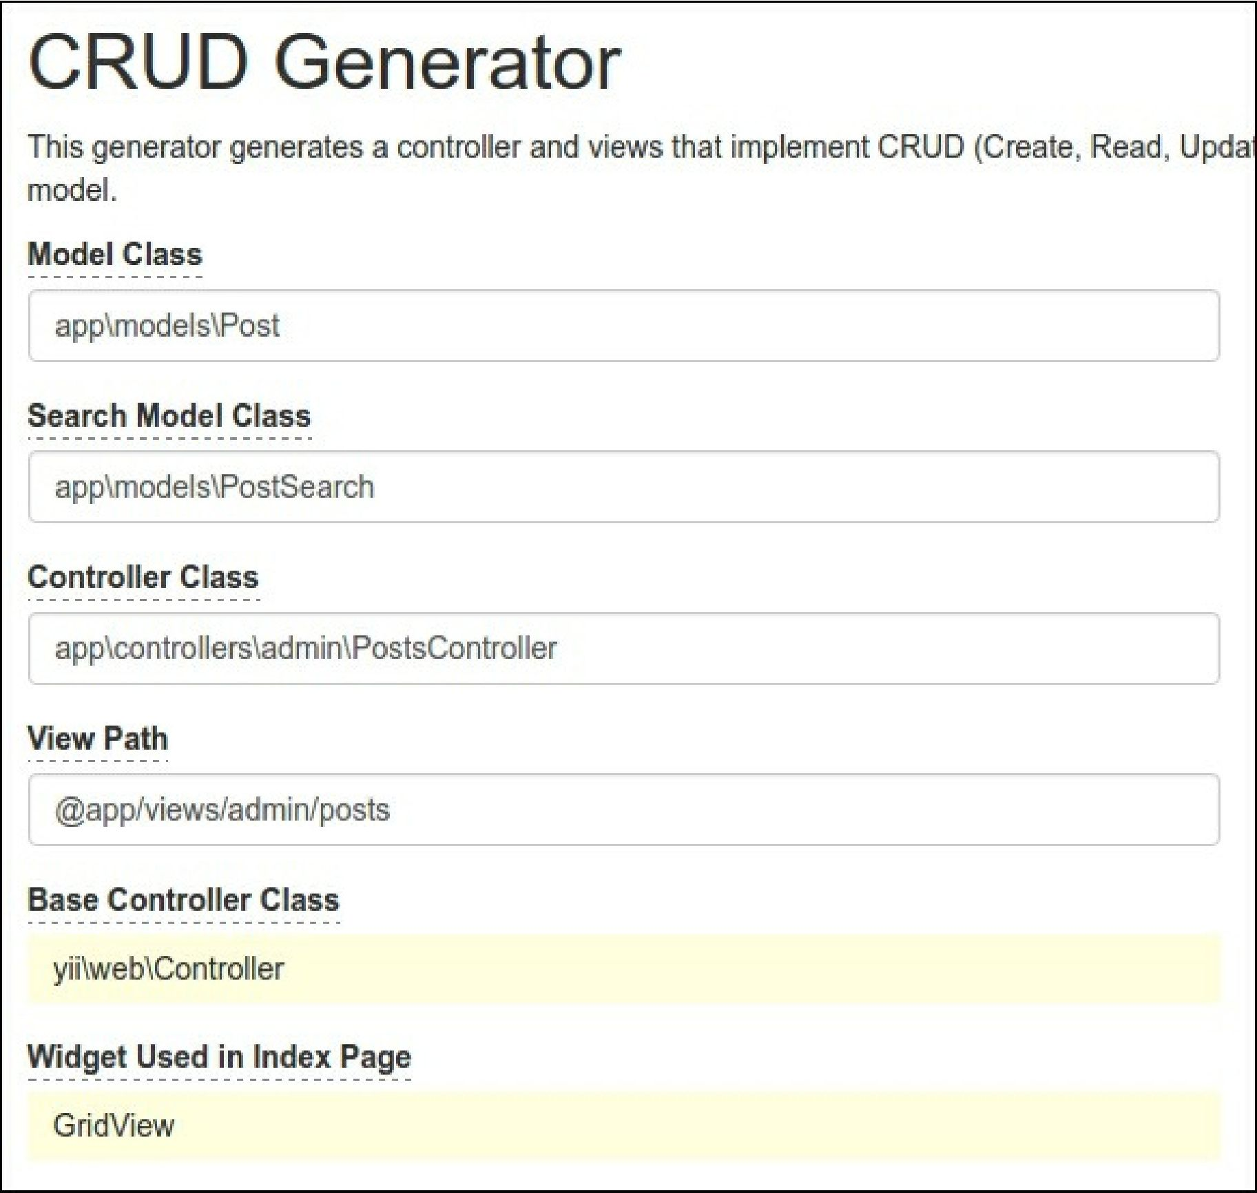

1. Also, add the status drop-down list for the status field and name for the submit button in views/admin/posts/_form.php:

<div class="post-form">

<?php $form = ActiveForm::begin(); ?>

<?= $form->field($model, 'title')->textInput(['maxlength' => true]) ?>

<?= $form->field($model, 'text')->textarea(['rows' => 6]) ?>

<?= $form->field($model, 'status')->dropDownList(Post::getStatusList()) ?> <div class="form-group">